Ukrainian Crisis Impacting Refugee Youth Speaker Bios

Sandra Mattar PsyD
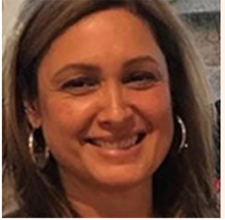

Dr. Mattar is a Clinical Psychologist, Assistant Professor, and Director of Training of the Immigrant and Refugee Health Center at Boston Medical Center. She is a graduate of the William James College (formerly MSPP), and the Universidad Católica Andres Bello (Venezuela). She is a licensed psychologist with more than 20 years of clinical and teaching experience combined. She has done field research around war trauma in Lebanon. Dr. Mattar was Associate Dean of the Kalmanovitz School of Education and Associate Professor in the Graduate Counseling Program at Saint Mary’s College of California. Dr. Mattar is a founding member of the Division 56 (Trauma Psychology) of the American Psychological Association (APA), and is a Past Chair of the Committee on Ethnic Minority Affairs of APA. She was a contributor to the APA Race and Ethnicity Guidelines Task Force. Dr. Mattar’s research interests are on the intersection of psychological trauma and culture; immigrants and refugee mental health; mental health disparities; multicultural and international psychology; culturally responsive, trauma-informed education and training, and mindfulness and spirituality. She is currently an Associate Editor for the Journal of Psychological Trauma. Dr. Mattar is bilingual in English and Spanish and speaks conversational Arabic and French. She holds a Yoga Teacher certification (RYT500).

Lindsey Martin, NP
Director of Global Disaster Response and Humanitarian Action
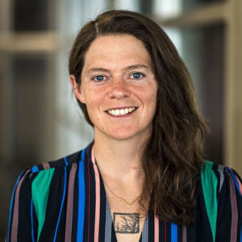
Lindsey is Director of Global Disaster Response and Humanitarian Action at Mass General. Lindsey is trained as a critical care Nurse Practitioner with a focus on surgical critical care and trauma. After starting her NP career at University of Maryland Medical Center-Shock Trauma she joined the Blake 12 surgical ICU at Mass General in 2015. Lindsey’s work in disaster response began at the same time as a volunteer on the Global Disaster Response Team. Her deployments have included the 2015 Nepal Earthquake, 2016 Hurricane Matthew in Haiti, 2017 Hurricane Harvey in Houston and Maria in Puerto Rico. She has assumed the role of Team Leader on multiple deployments most recently leading a 26-member medical EMAC to Ponce, Puerto Rico. In addition, she has participated in multiple training exercises and disaster simulations with MGH and its partner organizations.
Lindsey also has worked as public health clinical faculty at Northeastern University and has training in wilderness medicine and pre-hospital care as an EMT. Other international work includes volunteering with the Treatment Action Campaign in South Africa. She has her Masters in Global Public health from Brown University and is presently in the DNP program at Mass General in Boston
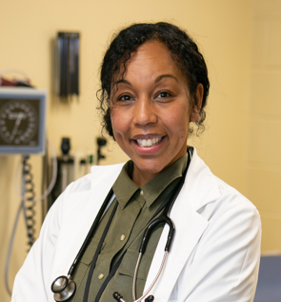
Nicole Kazarian, MSN, RN, NCSN is a bachelor’s prepared, nationally certified registered school nurse who obtained her MSN (Master of Science in nursing) degree from Worcester State University with a nurse educator specialization in May of 2020. Serving as a school nurse for over 24 years for the Worcester Public Schools, Nicole was appointed nursing supervisor in the fall of 2020. Nicole brings her passion for school health and love of advocacy for the needs of children to her role as nursing supervisor. Nicole has been instrumental in helping guide the WPS through the pandemic, helping to create protocols and disseminate COVID-19 guidelines to all members of the school district. She also empowers staff to maintain their levels of professionalism within their school environments as the sole health care providers in their schools.
Nicole’s background in emergency medicine, acute hospital, and home care further serve to support school nurses to provide safe care to children, as well as those who require individualized plans of care to come to school ready to learn. Nicole also serves as an adjunct clinical faculty member for Quinsigamond Community College’s RN to BSN program. For leisure, Nicole is a competitive scrabble player who completes locally and nationally. She is married with 2 adult children and enjoys vacationing with her family to Cape Cod.

