****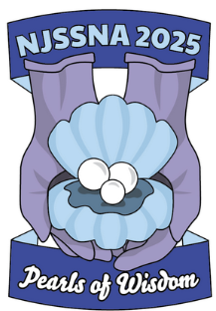





**AGENDA**

****[**Speaker & Session Information**](https://docs.google.com/document/d/1_6mIsmtWF7KGlWDZ8Blo3FzmnmQPBOPB/edit?usp=sharing&ouid=110209826388222661609&rtpof=true&sd=true)

**FRIDAY**

5:00 pm **Conference sign-in,** Poster Viewing

6 pm-9 pm **Dinner: "How to Be Positively Unforgettable": The Transformative Power of**

**Empathy, Kindness, and Generosity**

Tena Brown, Empathy Educator

**SATURDAY**

7:15 am **Conference sign-in, Breakfast, Sponsors/Exhibitors, Poster Viewing** (7:30 am)

8:00 am **Opening Ceremonies**

**School Nurses are Chief Wellness Officers**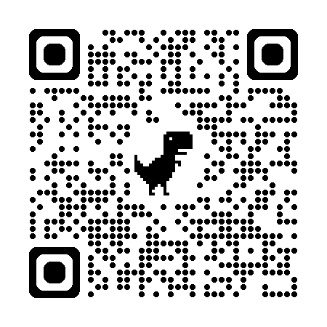

Robin Cogan, MEd, RN, NCSN, FNASN, FAAN

9:30 am **Break & Browse** Raffles, Sponsor/Exhibit Hall, Poster Viewing

9:45 am **What's Changed and What Hasn't: Understanding Evolving Legal**

**Requirements in School Health** David Nash, Esq.

10:45 am **Break & Browse** Raffles**,** Sponsor/Exhibit Hall, Poster Viewing

11:00 am **Morning Breakout Sessions**

12:00 pm **Lunch & Learning**: Professional Headshots/Group Photo Ops

|  |  |  |
| --- | --- | --- |
| Time | **Blue Team** | **Yellow Team** |
| 12:10-12:55 pm | **Lunch** | **Sponsor/Exhibitors, Pump/Tube School, Posters** |
| 1:10-1:55 pm | **Sponsor/Exhibitors, Pump/Tube School, Posters** | **Lunch** |

2:00 pm **Afternoon Breakout Sessions**

3:00 pm **Break & Browse** Raffles**,** Sponsor/Exhibit Hall, Poster Viewing

3:15 pm  **School Nursing Evolved: NASN’s Refreshed School Nursing Practice FrameworkTM**

Terri Hinkley, EdD, MBA, BScN, RN, CAE (CEO NASN)

4:15 pm **Closing** Raffles Have a safe drive home!

Northeastern University School of Nursing is accredited as a provider of nursing continuing professional

development by the American Nurses Credentialing Center's Commission on Accreditation. To obtain nursing contact hours, attend all sessions, missing no more than 5 minutes per session.

**Thank you to our Sponsors and Exhibitors for supporting our conference!**